 

ACM, VISAKHAPATNAM

Seminar on GPU Technology EVENT REPORT

# Summary

ACM, GITAM in collaboration with VIT CSI has conducted the event "Seminar on GPU Technology" This event is conducted to introduce the concepts of GPU technology and its Architecture, and its use cases in our day to day life. The speaker of the session was Prof. Sandeep Manne. The event also had attendees from other institutions which are a part of the collaboration. The event was organized on 12/12/2021 from 11:00 AM to 12:30 PM, and the participants attended the event in online mode- Microsoft Teams.

The publicity and registrations for the event started two days before the event, and students were sent the event's details through the club's official mail id. A WhatsApp message was also circulated briefing about the event, and all the details of the event were mentioned there. The posters and videos regarding the event were shared on various social media handles such as Instagram and LinkedIn. 116 participants attended the event.

By the end of the event the attendees understood the fundamentals of GPU technology and its Architecture.They were also briefed about the GPU Technology which helps the user in other domains such as Machine Learning , Video Editing and Gaming Applications.Attendees appreciated the event, and the event was a great success.

 

# Photographs

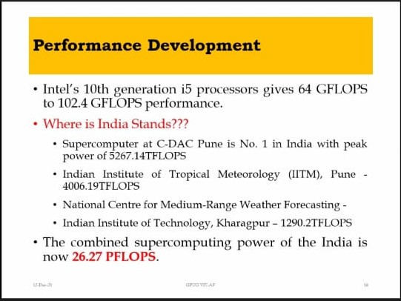

 

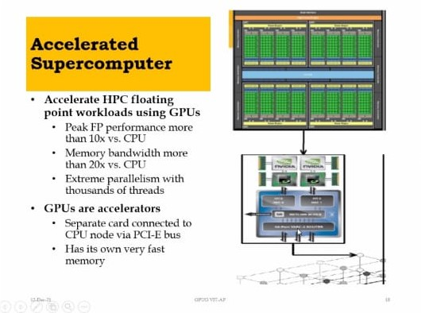

 

ACM, VISAKHAPATNAM

Seminar on GPU Technology

# Event Snapshot

|  |  |
| --- | --- |
| **EVENT SNAPSHOT** | |
| Event Name: | Seminar on GPU Technology |
| Organizing Club: | ACM |
| Event Date: | 12/12/2021 |
| Event Time: | 11:00 AM to 12:30 PM |
| Event Mode / Venue: | Online - Microsoft Teams |
| Social media reach: | Instagram: @gitam_acm  LinkedIn: https://[www.linkedin.com/company/acm](http://www.linkedin.com/company/acm)  -gitam-association-for-computing- machinery/mycompany/ |
| Registrations: | 50 from GITAM |
| Number of Participants/Attendees: | 116 |
| Winners (if any): Name - Regd ID - Email ID | NA |
| Faculty - Judge - Guest Speaker: | Prof. Sandeep Manne |
| Event Report Author - Designation: | Guru Charan - Event Manager Lead. Sejal Reddy. - Event Manager.  Sravya– Event Manager.. |